Inteligent Driving
Engineering
and
Autonomous Systems,
an Engineering Competition

Table of contents

1 System Overview 3
2 General competition rules 3
3 System and track specifications 4
3.1 General system requirements 4
3.2.1 Car electronics hardware requirements 5
3.2.2 Client-server protocol requirements 6
3.2.3 GUI requirements: 6
3.3 Track specifications 6
4 Evaluation 10
4.1 Project Presentation 17
4.2 Race on the track 17

Project goal: Each team shall build one system; the team that achieves the TIER requirements will win the respective tier prizes.

1 System Overview

The project requires a solution towards solving the autonomous city vehicle problem, for this stage it needs to have implementations for Lane Keeping Assist (LKA), Traffic Sign Assist (TSA) and Collision Detection/Avoidance (CDA) and Wireless Charging (Qi Technology).

Whenever they are used in the subsequent chapters, the terms below have the following meaning:
Car = vehicle which implements all related requirements
Smart phone = a device which implements all related requirements
System = Car + Smart phone
GUI = Graphical User Interface
RF = Radio Frequency
Control board = electronic circuits which integrate the car logic command (software). From hardware standpoint, this is the board which integrates the micro controller
Inverter = electronic circuit used to command the BLDC motors
SW = Software developed or integrated by the team and deployed on the car and Smart phone
HW = Electronics hardware
PC¹ = PedestrianCrossing¹
SS² = StopSign²
PS³ = ParkingSign³
CS⁴ = Charging Station⁴
ML = Machine Learning
TSA = Traffic Sign Assist
CDA = Collision Detection Assistance
LKA = Lane Keeping Assistance
DNF = Did Not Finish
WPT = Wireless Power Transmitter
QiC = Wireless Qi Charging Enabled Device
TL⁵ = Traffic Light (^{green, red, yellow})

2 General competition rules

- Each team must have 3 or 4 members, all members can be Continental AG working students.
- Each team shall participate in the competition with one system (replacement parts are allowed).
- Each car shall be able to run independently on a predefined track within its designated lane from the Start Area to the Stop area denoted by the space of 0.95 m (~one meter) after the PS³ (Race mode – autonomous driving stage).
- Each car is required to detect a charging station and signal its presence with a blinking WHITE LED.
- Each car shall have a charging station protocol implemented.
- If a charging station is detected trough the presence of the CS⁴ the charging protocol must be initiated.
- Each car is required to fit a Standard Dimension in terms of W:30cm L:42cm and H:27cm (regular dimensions for a A3 standard paper size).
  - NOTE: this rule is compulsory, failure to achieve this will result in disqualification
- Steering will be ensured either by using an electric motor of any type (might be an off-the-shelf electric actuator) on a steering shaft/ arm or by different speeds for each traction wheel
- While running, the car shall be able to transmit several car parameters to the Smart phone (Using only Wi-Fi connectivity) using a client-server protocol communication system. Detailed requirements are presented in the following chapters.
- Each team shall document the hardware, software and mechanical concepts in a design document, required for Design_challenge_1.
- The competition will be organized by the Continental Iasi location. Each year the contest location will be announced in advance.
The Team which Verifies all Conditions for TIER1 will win the TIER1 Prize (only one prize awarded)
The Team which Verifies all Conditions for TIER2 will win the TIER2 Prize (only one prize awarded)
The Team which Verifies all Conditions for TIER3 will win the TIER3 Prize (only one prize awarded)
If a team has the same point for a TIER the difference will be made using the points accumulated from Design Challenge, if these points are also the same, the difference will be made by Average Lap Time. If this is also the same the race will be redone.
- The re-flashing/calibration and adjustment of the car are allowed at any time during the entire competition day.
*Note:
Electrostatic discharge issues due to the building ground (where the final phase of the contest will be held) should be considered by the participating teams. Protection mechanism for the designed electronics should be considered.

3 System and track specifications

3.1 General system requirements

R1: Each car shall be able to run in Autonomous driving mode, on a predefined race track from the START line to the PS³ area.
Remark: in Autonomous driving mode no external human intervention on the car is allowed during the laps on the track, except for the Start/Stop command which is permitted (up to 4 tries)
R2. The traction shall be realized with at least one electric motor (BLDC, DC).
R3: Each car shall be powered by batteries and these batteries must be carried by the car.
R4: Each car shall have a built-in wireless charger. (QiC)
R5: Each car shall communicate wirelessly with a Smart phone, without interconnecting nodes.
R6: Each System shall include one GUI, which shall run on the Smart phone and shall display the information exchanged by the car and the Smart phone.
R7: Each car must be equipped with devices able to recognize at least 4 distinct traffic signs and a Traffic Light. (TSA)
- PedestrianCrossing¹
- StopSign² ParkingSign³
- Charging Station⁴
- Traffic Light⁵
R8: Each car must be equipped with devices able to detect frontal obstacles.
R9: When detecting obstacles, the car shall react in the following way Avoid and Continue. (CDA)
R10: The Total Lap time (Start to Park) or Time to milestones (in case the car is DNF) will be measured and count towards winning/losing the current round.
R11: The Car must be equipped with devices able to detect the lane in which it should stay and keep throughout the race. (LKA) If the car goes out of its lane (with all 4 wheels) it will be penalized with 1 second for each second it is out of bounds, except for R9 – (CDA).
R12: Each car shall be able to stop within 0.95 m in front of SS² and PC¹, before or after will result in 10 second penalization, with at least 2 wheels only.
R13: Each car shall be able to stop within 0.95 m after the PS³ before or after will result in 15 second penalization, with all 4 wheels only.
R14: Each car shall be able to stop on the charging pad in the CS⁴ area for 5 seconds, after which it must back up into the lane and resume its lap. (Wireless Charging), failure to consider this rule or ignoring applies a penalty of 20 seconds.
R14: Each car shall be able to acknowledge the presence of a charging station. A charging station protocol shall be implemented as follows:
- After detecting CS⁴ the car shall pass into the designated charging area.
- The car must stop on the charging pad at least 5 seconds.
- Detailed measures are presented in the Figure 1 to 4, regarding size location and position of the charging area.
- The batteries of the car shall be charged through inductive charging (on the QiC standard), it is not necessary to fully charge the battery, can be only a demonstration of the feature.
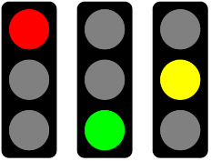
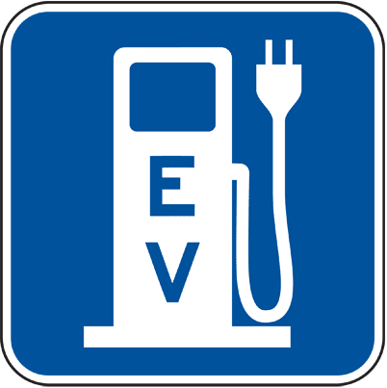
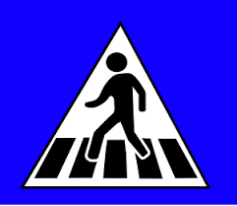
R15: Each car shall have the following behavior for:
PC¹ – Stop for 1 second (within the above-mentioned area) and then continue the race.
SS² – Stop for 3 second (within the above-mentioned area) and then continue the race.
PS³ – Full-Stop (within the above-mentioned area) to finish the race.
CS⁴ – Enter the designated area and light a charging LED for 5 seconds.
TL⁵ – TL^{red} (wait for green), TL^{yellow}(wait for green), TL^{green}(pass unobstructed)
R16: Each car shall have a debugging console which will log all car actions for a single drive. The log must be saved in a readable format to be provided to the judges if requested.
Examples:
<<INFO>> 2017:09:22 – 14:55:03 – Car direction RIGHT
<<INFO>> 2017:09:22 – 14:55:05 – Car direction FORWARD
<<INFO>> 2017:09:22 – 14:55:15 – Car Detected STOP SIGN
<<INFO>> 2017:09:22 – 14:55:18 – Car STOPPED for 3 Seconds
<<INFO>> 2017:09:22 – 14:56:25 – Car Detected Obstacle
….
R17: Cybersecurity shall be considered, basic security steps must be proved (login, basic encryption, certificates, signatures, etc).

3.2.1 Car electronics hardware requirements

R18: The traction motors must be driven by motor controllers, evaluation will be done only on the chosen solution.
R19: The control board can be manufactured by the team (option preferred) or a development kit can be used.
R21: Connecting wires shall be bound together in pairs for specific functions, floating wires are not allowed.
R22: The wireless charger circuitry consists of 2 parts:
Detector: A WHITE Blinking LED (supplied with power by the QiC) shall indicate the presence of charging station;
Charger: Each car shall have a wireless charger receiver, which will should charge the car batteries.
R23: Each car shall have a Head-Lighting System which will cover the area in front of the car with flood lighting (Head-lamps for night lighting)

3.2.2 Client-server protocol requirements

R25: Each system shall implement one communication protocol of the client-server type.
R26: The communication protocol support must be a WIFI standard, without interconnecting nodes. Routers are permitted.
R27: The communication protocol and the communication type must be detailed in the design document.
R28: In Diagnosis mode the car must provide detailed diagnostic info about its running parameters. (See R16)

3.2.3 GUI requirements:

R29: The system must include one GUI to display the information received from the car.
Remark: The GUI must be displayed on a Smart phone exclusively.
R30: The car status displayed on the GUI shall not be older than 5 seconds.
R31: The GUI shall implement two working modes: Autonomous driving and Diagnosis modes.
Remark: The Diagnosis modes will be used only during the Design_Challenge evaluation. Autonomous driving mode will be used during the Race_Challenge races on the track.
R32: In Autonomous driving mode, the Smart phone must be able to send only the START command. The STOP command to the car will be used for emergency situations.
R33: The GUI must display the following information received from the car, in all modes:
- the time elapsed from the START moment. The timer shall stop when the car reaches the PS³ Area
(Autonomous driving and Diagnosis mode);
- the battery level (Autonomous driving and Diagnosis mode);
- the charging state *Not Charging, *Charging (Autonomous driving and Diagnosis mode);
- the car speed (Autonomous driving and Diagnosis mode);
- the distance travelled by the car from the start point (Autonomous driving and Diagnosis mode);
- the left/right traction wheels status – moving forward/backward or stopped
(Autonomous driving and Diagnosis mode);
- Traffic Sign/Light Detection status/ Sign Detected (Autonomous driving and Diagnosis mode);
- Thermal sensors (Diagnosis mode);
- Charging stations Voltage (Diagnosis mode);
- Charging remaining time (Diagnosis mode);
- Sensors/Camera Status, (Diagnosis mode);
- Any data from motor controllers and battery charger (Diagnosis mode);
Remark: In the Diagnosis mode, all the car functional requirements must be available and testable.

3.3 Track specifications

T1: The track shape and its dimensions are presented in Figure 1.
Remark: The participants shall consider a tolerance of 10% between the drawing and the real track dimensions.
T2: The track running surface is made of thermoplastic material (PES): SIOEN B7119/ color code GREY for the asphalt and WHITE for the markings.
T4: The Start line is marked on the race track by an arrow, pointing in the appropriate direction.
T5: The Stop area is marked on the race track by a drawn line PS³ traffic sign and 0.95 m in front of the sign.
T6: The entire surface of the track is flat.
T7: Each Traffic sign will have the actual sign dimensions fit within 21x21 cm (only the actual sign)
T8: The column for each sign will measure 21 cm from the ground to the margin of the sign.
T9: The Traffic Light will measure 21x7cm.
T9: Apart from the track curves, two obstacles will be placed on the track. The usage and the placement of the obstacles will be decided by the organizers during the competition day.
T10: The obstacle position on the track will be the same for all the participants and it will be defined by the organizers.
T11: Each obstacle will obstruct approximately 40% of the track width.
T12: The lane markings have a 30mm width
T13: Each car must stop at least once during the entire race (either of 2 laps) on the charging station denoted by the traffic sign CS⁴ for at least 5 seconds, failure to do so will result in a 20 seconds penalty.
T14: The charging station consists in a trapezoidal area with 3 walls of 21 cm height and a charging pad (see dimensions in Fig. 1).
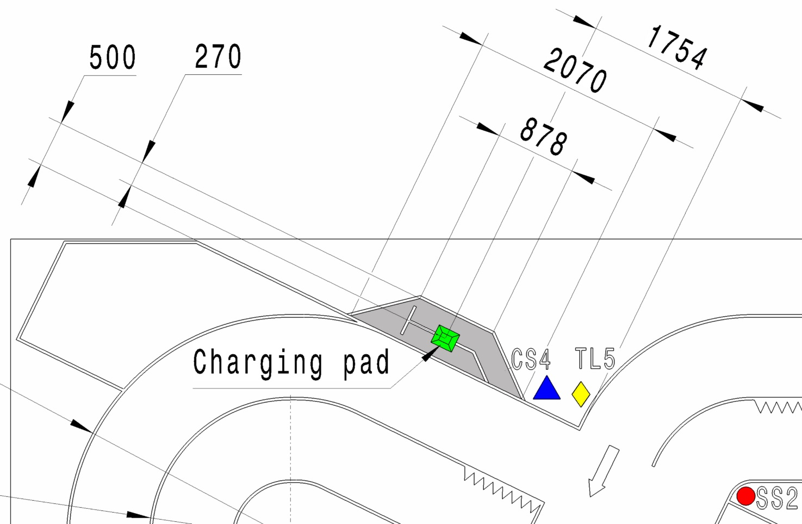
Figure 1 Charging station details

In order to ensure that the car get into the charging station, some solutions can be used as follows:
- possibility to use the signs marked with red (Ø 90 mm) on the walls (Fig.2, Fig.3);
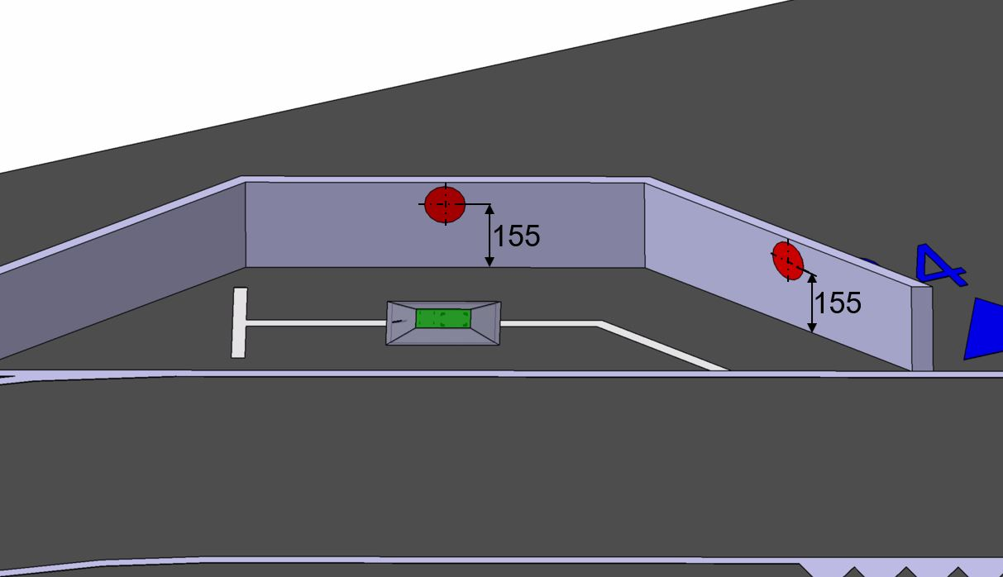
Figure 2 Charging station isometric view- Position of the red signs center
related to the flat surface of the track

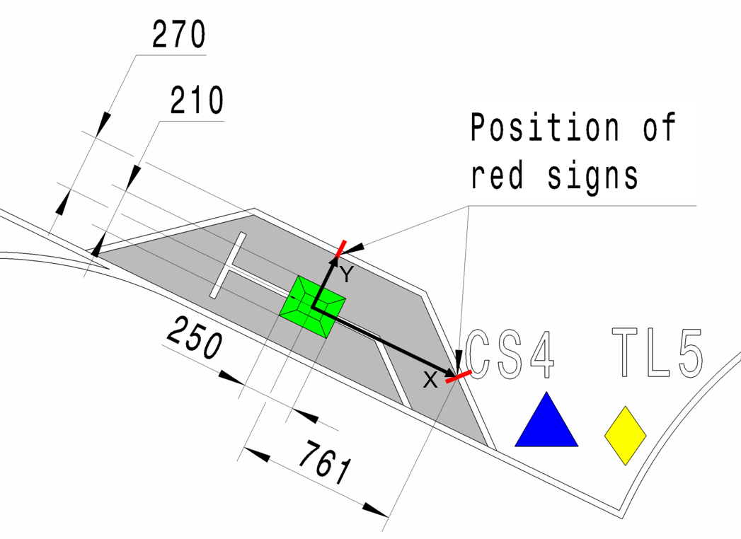
Figure 3 Charging station – Position of the red signs center
related to the center of the charging pad (on x, y- axis)

- possibility to use the white path (30 mm width) from the charging station area (Fig. 4);
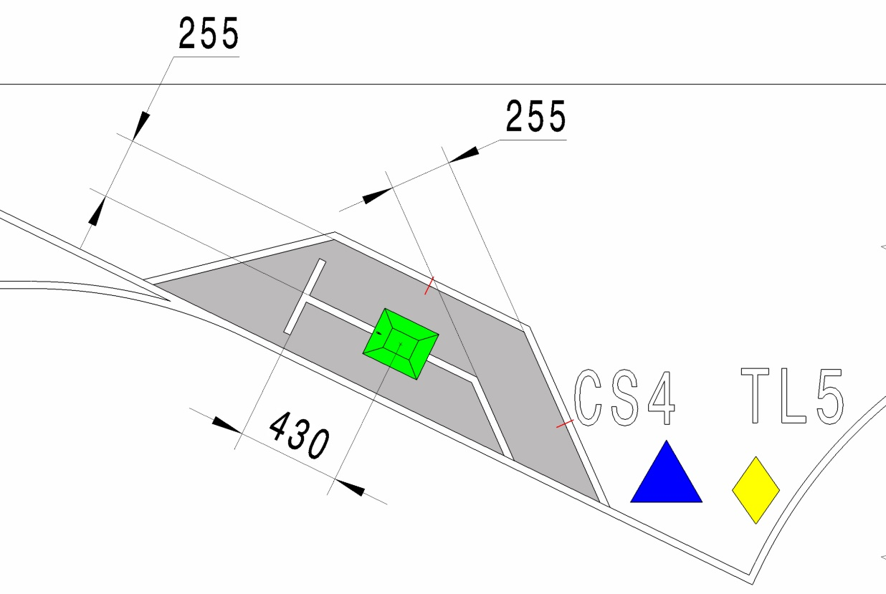

Figure 4 Charging station- details for the white path
- any other solution can be implemented.
3.4 Car Qualification Minimum Requirements (Eliminating rules)

Q1: Car must have a blinking WHITE LED light for the charging station, located in the middle of the intersecting diagonals of the car, orientated upwards, with a 360* light angle.
Q2: Car must fit a 42 cm on L 30 cm on W 27 cm on H
Q3: Prizes will be awarded for TIER requirement achievements please see TABLE XXX
Q4: All Design Challenge Evaluations are mandatory, At least 1 Team member must be present for each session. Evaluation will be done base on the criteria ( marked with yes ) for each Design_Challenge Milestone please see Tables 3-5

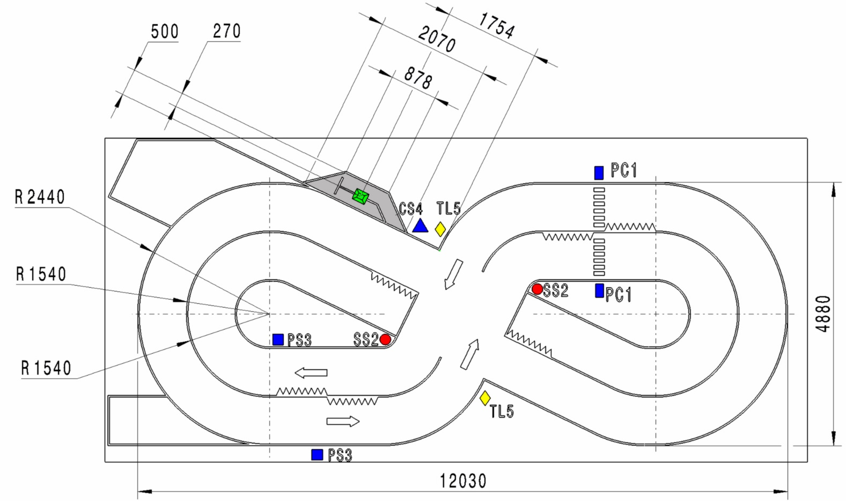
Figure 4 Track dimensions
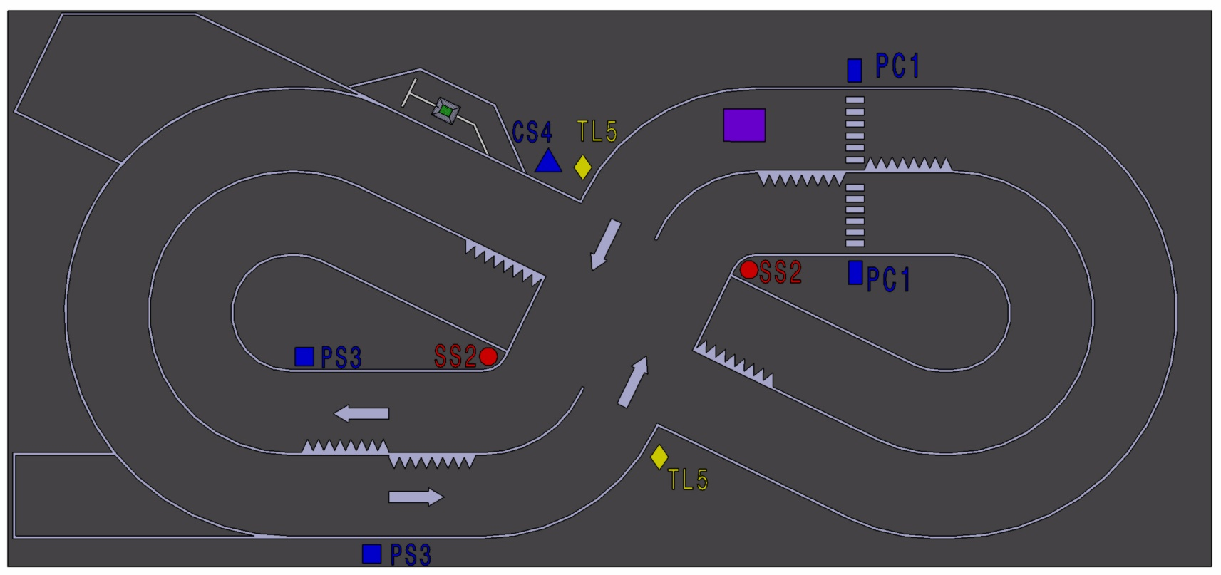
Figure 5 Track Signs locations

Observation for Figure 5: An example position for obstacles (represented in purple) are just for your information. The positions will be defined by the jury and might be different than depicted.

4 Evaluation

The competition shall be evaluated as follows:

Design Challenge: All the evaluation criteria are listed in Table 1.
Design Challenge: evaluation criteria | Points | Reference
Inteligent Driving Criteria | 20 | Table 3
Engineering Criteria | 30 | Table 4
Autonomous Systems Criteria | 20 | Table 5
Total | 70 | TECH REQ

Table 1

The project design document and status report documents are evaluated based on:
- Project Design document Required for Design_Challeng_1
- Design_Challenge Milestones will be in 4 (four) stages.

Design Challenge will define the order by which teams that will go to Race Challenge.

Race Challenge: All the evaluation criteria are listed in Table 2.
No | Race Challenge Criteria evaluated after each 2 laps round | Race Challenge Penalty or Points | TIER1 Achievements | TIER2 Achievements | TIER3 Achievements
1 | A lap will be considered finished when the all 4 wheel(s) of the car are within the 0.95m length PS³ | 15sec | Yes | Yes | Yes
2 | The car must stop for 1 second within 0.95 meter before the PC¹ traffic sign, | 10sec | Yes | Yes | Yes
3 | The car must stop for 3 second within 1 meter before the SS² traffic sign | 10sec | Yes | Yes | Yes
5 | The car must be able to steer and stop at the charging station and light an LED for 5 seconds, | 20sec | Yes | Yes | Yes
6 | The car shall keep its designated lane for the entire drive, any lane departure (at least 4 wheels, crossing the separation line) will earn a penalty of 1 seconds for every second it is out of bounds, the exception remaining when avoiding an obstacle. Separation line) | 1/sec | Yes | Yes | Yes
1 | The car shall depart from start position within 3 seconds | 1 | Yes | No | No
2 | The car shall depart from start position within 5 seconds | 2 | Yes | Yes | No
3 | The car shall depart from start position within 10seconds | 1 | Yes | Yes | Yes
4 | TGREEN the car shall pass the intersection unobstructed | 1 | Yes | No | No
5 | TYELLOW car shall brake to stop and wait for red | 1 | Yes | No | No
6 | TRED car shall stop and wait for green (max 5s) | 1 | Yes | No | No
7 | The car shall pass the intersection without any collisions or lane conflicts (first time) | 1 | Yes | Yes | Yes
8 | The car shall pass the intersection without any collisions or lane conflicts (second time) | 2 | Yes | Yes | No
9 | The car must stop for 1 second within 0.95 meter before the PC¹ traffic sign | 1 | Yes | Yes | No
10 | The car shall successfully pass the first hairpin | 2 | Yes | Yes | Yes
11 | The car shall successfully pass the second hairpin | 1 | Yes | Yes | No
12 | The car must stop for 3 seconds within 1 meter before the SS² traffic sign | 1 | Yes | Yes | No
13 | After waiting at SS² sign, the car shall not pass through the intersection if another vehicle is crossing | 1 | Yes | No | No
14 | The car shall recognize the CS⁴ traffic sign and steer for charging | 1 | Yes | Yes | No
15 | Charging station protocol fully implemented and running  - position the car at the station  - wait for 5 seconds | 1 | Yes | No | No
16 | Charging trough inductive charging enabled (does not have to charge the entire battery) | 1 | Yes | No | No
17 | After 5 seconds spent on the charging station the vehicle shall continue the lap | 1 | Yes | No | No
18 | Obstacle recognized and avoided (object will be placed in a random location on the lane obstructing 40% of its width) | 2 | Yes | Yes | Yes
19 | After completing the lap the car has not crossed its lane w/o reason for more than 15 sec | 1 | Yes | No | No
20 | After completing the lap the car has not crossed its lane w/o reason for more than 25 sec | 2 | Yes | Yes | No
21 | After completing the lap the car has not crossed its lane w/o reason for more than 35 sec | 1 | Yes | Yes | Yes
22 | A lap will be considered finished when the all 4 wheel(s) of the car are within the 0.95m length PS³ | 2 | Yes | Yes | Yes
23 | Time Spent for the race less than 1.5min | 1 | Yes | No | No
24 | Time Spent for the race less than 3min | 1 | Yes | Yes | No
TOTAL ACHIVABLE TARGET |  | 30 | 30 | 20 | 9
Table 2

The Prizes are won based on, in order of importance, Race_Achievements, Design_Challenge points, Autonomous Driving Stage average lap times.

Achievements from Race_Challenge, marked with Yes (Table 2) for TIER1, must be fulfilled to qualify for TIER1 prize, same applies for TIER2 and TIER3.

Design_Challenge Points will be used to separate teams with the same points average for each TIER.

If at least two teams have the same R and D points the Average Time will be considered, and if that is the same, the 2 will redo the race head to head. The Team with 2nd place from the race, will contest the next in line TIER.

TIER1 > 25 (max 30)
TIER2 > 15 (20)
TIER2 > 7 (9)

(Main GROUP)  Intelligent Driving | Evaluation criteria | Detailed evaluation criteria | Max category pts | Max possible pts | Design_1 evaluation | Design_2 evaluation | Design_3 evaluation | Design_4 evaluation
Car driving functions | L/R Motor(s) spin(s) FW, BW** and Steering functions, vehicle can steer. |  | 0.5 | 9 | yes | yes | yes | yes
 | Car recognizes at least 5 distinct traffic signs (PC¹, SS², PS³, CS4, TL) |  | 1 |  | no | yes | yes | yes
 | Car recognizes lanes |  | 1 |  | no | no | yes | yes
 | Car steers away when having frontal obstacles at a minimum distance of 30 cm |  | 0.5 |  | no | no | yes | yes
 | Car stops for at least 1 Second when recognizing the PC¹ |  | 1 |  | no | no | yes | yes
 | Car stops for at least 3 Seconds when recognizing the SS² |  | 1 |  | no | no | yes | yes
 | Car stops when recognizing the PS³ |  | 1 |  | no | no | no | yes
 | Car merges into station when recognizing the CS⁴ |  | 1 |  | no | no | no | yes
 | Charging station detected and vehicle parks for charging. |  | 1 |  | no | no | no | yes
 | Car detects traffic lights TL^{red} Tl^{yellow} Tl^{green} and has protocols implemented for it, details in the general rules.( R>>>>) |  | 1 |  | no | no | yes | yes
Car remote control | Communication | Wi-Fi only | 1 | 2 | no | no | yes | yes
 |  | Understanding of the communication protocol and Cybersecurity measures taken. | 1 |  | no | no | yes | yes
 | GUI | Start/Stop commands available (Ignition key). | 1 | 4 | no | no | yes | yes
 |  | Display the car FW/BW/L/R movement direction. | 1 |  | no | no | yes | yes
 |  | Display the speed and battery level (Cluster board) record the time and distance of the drive. | 1 |  | no | no | yes | yes
 |  | Display diagnostic data, and recognized sign. | 1 |  | no | yes | yes | yes
Car features for people mobility | 2WD or 4WD configuration with Ackermann steering | Proof for Ackermann angles/ Ackermann ratio | 1 | 3 | no | yes | yes | yes
 |  | Integration of differential on power axle(s) or torque vectoring. | 1 |  | no | yes | yes | yes
 | Proposal for innovative transport | Integrate in vehicle new concepts that will improve people transportation and accessibility from the community perspective | 1 |  | no | no | yes | yes
Understanding and Innovation | Examples, not restricted to:  - Theoretical understanding and design methodology;  - Necessity for Ackermann steering;  - Necessity for differential (mechanical) or torque vectoring (virtual differential);  - Methodology for choosing the vehicle architecture (no. of wheels, steering, etc);  - Innovation (design or manufacturing). |  | 1 | 2 | no | yes | yes | yes
 | Understanding ( examples, not restricted to ):  - Usage of NN on the car to learn>train and understand the track, signs and obstacles.  - Implementation of SW mechanisms for easy debugging with complete logging.  - Efficient S/W design, with high reusability and ease of reconfiguration. |  | 1 |  | no | no | no | yes
TARGET |  |  | 20 | 20 | 0.5 | 5.5 | 16 | 20
Table 3

(Main GROUP)  Engineering | Evaluation criteria | Detailed evaluation criteria | Max category pts | Max possible pts | Design_1 evaluation | Design_2 evaluation | Design_3 evaluation | Design_4 evaluation
Mechanical Car Design | Mechanical construction | Car aerodynamic shape | 1 | 6 | no | no | no | yes
 |  | Stability of the car | 1 |  | no | no | no | yes
 |  | Compact construction | 2 |  | no | no | no | yes
 |  | Concept originality | 2 |  | no | no | yes | yes
Degree of mechanical design integration | Mechanical design for at least one major subassembly  OTHER THAN BODY | - Proof of mechanical design (CAD, sketches, calculations etc) for at least one major subassembly;  - Major subassembly might be (but not restricted to): front axle including uprights rear axle including final transmission (reduction gear), steering mechanism;  - Remaining vehicle components (e.g. main frame) build-up from off-the-self components (e.g. Lego or Meccano parts);  - Only individual parts might come from industrial products (e.g. wheels/ hubs, steering rms, bearings, etc.). | 6 | 8 | no | no | yes | yes
 |  | Concept of an innovative chassis. | 2 |  | no | no | yes | yes
 | OR |  |  |  | OR
 | Mechanical design for at least one component  OTHER THAN BODY | - Partial vehicle carry-over with proof of mechanical design for at least one component (CAD, sketches, calculations, etc.);  - Component might be (but not restricted to): uprights; steering arms, reduction gear, main frame. | 4 |  | no | no | yes | yes
 | OR |  |  |  | OR
 | Only integration of existing components and subassemblies | - Complete vehicle carry-over (e.g. existing RC model car or toy);  - Only mechanical integration of existing components (motors, PCB fixations, cooling elements, other HW components, etc). | 1 |  | no | no | yes | yes
Motor controllers & Powertrain | Developed | Developed (schematics, layout, concept, diagnosis, diy PCB, gearbox homemade or used from another device) | 6 | 6 | yes | yes | yes | yes
 | OR |  |  |  | OR
 | Bought | Bought module from the internet. | 1 |  | yes | yes | yes | yes
Understanding and Innovation | Understanding (Examples, but not restricted to):  - An ECAD tool is used to demonstrate HW competences;  - Relevant principles are used in design of Schematics & Layout;  - Argument enforced HW circuits types  - HW Efficiency implemented and understood |  | 5 | 10 | no | no | no | yes
 | Examples, not restricted to:  - Theoretical understanding and design methodology  - Methodology for choosing the vehicle architecture (no. of wheels, steering, etc);  - Innovation (design or manufacturing) |  | 5 |  | no | yes | yes | yes
TARGET |  |  | 30 | 30 | 6 | 11 | 21 | 30
Table 4

(Main GROUP)  Autonomous Systems | Evaluation criteria | Detailed evaluation criteria | Max category pts | Max possible pts | Design_1 evaluation | Design_2 evaluation | Design_3 evaluation | Design_4 evaluation
Battery charger | Developed (schematics, layout, concept, diagnosis, soldered PCB) |  | 5 | 5 | no | no | yes | yes
 | OR |  |  |  | OR
 | Bought |  | 1 |  | no | no | yes | yes
Control Board | Additional board was developed | Created PCB to ease interconnect with peripherals (schematics, layout, concept) | 4 | 4 | no | yes | yes | yes
 | OR |  |  |  | OR
 | RPi or equivalent (dev-boards) used as main board | No extra PCB was made to extend the GPIO-s | 1 |  | no | yes | yes | yes
Autonomous driving strategy | Machine learning algorithm Implemented with self-correcting mechanisms, implemented for Track detection and Sign Recognition |  | 5 | 5 | no | no | yes | yes
 | OR |  |  |  | OR
 | Implementation of a fuzzy logic algorithm based only on experiments is considered as less effort and know how. |  | 3 |  | no | no | yes | yes
Understanding and Innovation | Understanding ( examples, not restricted to ):  - Deep learning library choice ( if chosen at all ex: OpenCV, TensorFlow)  - Usage of NN to control the motor functions  - Usage of NN on the car to learn>train and understand the track, signs and obstacles.  - Implementation of SW mechanisms for easy debugging with complete logging.  - Efficient S/W design, with high reusability and ease of reconfiguration. |  | 3 | 6 | no | no | no | yes
 | Understanding (Examples, but not restricted to):  - An ECAD tool is used to demonstrate HW competences;  - Relevant principles are used in design of Schematics & Layout;  - Argument enforced HW circuits types  - HW Efficiency implemented and understood |  | 3 |  | no | no | no | yes
TARGET |  |  | 20 | 20 | 0 | 4 | 14 | 20
Table 5

4.1 Project Presentation
Each team shall make a brief presentation of the project (e.g.: ppt) – with a duration of maximum 5 minutes and present it in front of the jury, visitors and competitors. All the competing teams will present their materials using a computer (which will be equipped with at least Microsoft Office) and a projector provided by the organizers. The presentation shall be focused on the technical details of the car. Presentation skills, aesthetics, design, marketing, as well as general impression left by the presenters will be valued.

4.2 Race on the track
The race on the track is carried out in 1 Stage Autonomous driving Stage – detailed below.

There will be 3 rounds.
Each team will run once per round.
To determine the competition order, the results from the Design_Challenge will be used.
Each round participant will run on the outer lane, giving equal chances to all.

Example:
If 19 teams are present after Design_Challenge only 16 (2⁴) teams will compete one-on-one in Autonomous driving Stage.
Autonomous driving
Rank | Team
1 | Team A
2 | Team B
3 | Team C
4 | Team D
5 | Team E
6 | Team F
7 | Team G
8 | Team H
9 | Team I
10 | Team J
11 | Team K
12 | Team L
13 | Team M
14 | Team N
15 | Team O
16 | Team P
17 | Team Q
18 | Team R
19 | Team S
Legend: The green colored cells qualify the teams for Autonomous driving Stage

Figure 6

The cars which do not finish the entire lap will be ranked depending on the distance covered on the track.

Rules for the race on the track within this stage:

- All the cars will start the race from the START line,
- Each car will run on the outer lane, (Best Lap Time will be saved) 3 times.
- 0.95 meter in front of the START line is the designated PARK SIGN space, a PS³ will signal the car where that is.
- From standstill position at the START line, the car is started by the pushing of the START button available on the Smart phone and only that, no other devices are allowed.
- One lap will be considered finished, when the car stops within the 0.95-meter area from the PS³ with all 4 wheels, otherwise the team will get a penalty of 15 seconds.
- The car must finish the lap in 5 minutes or less, otherwise the distance, where the car is after 5 minutes, will be considered to calculate the points.
- The car must stop for 1 second within 0.95 meter before the PC¹ traffic sign, stopping outside of the area or failure to stop will earn a penalty of 10 seconds.
- The car must stop for 3 second within 0.95 meter before the SS² traffic sign, stopping outside of the area or failure to stop will earn a penalty of 10 seconds.
- The car shall keep its designated lane for the entire drive, any lane departure (at least 4 wheels, crossing the separation line) will earn a penalty of 1 second for every second it is out of bounds, the exception remaining when avoiding an obstacle.
- The car must avoid contact in case it encounters obstacles on its lane, in this situation it is permitted to temporarily depart from the lane (only in the case of obstacle avoidance).
- The race order is done based on Design_Challenge_4 points.
- In this stage, 1 race will take place with each round (3 rounds in total):
  - Only one car will run on the track on the outer lane having as a target to obtain the best individual result (Time and Points/Achievements).
  - Being on the outer lane, each round, the team will have a chance for stopping at the charging station for 5 seconds.
    - Failure to consider the pad and light the LED for 5 seconds or completely ignoring the pad earns a penalty of 20 seconds.
    - All the same the chance to qualify for TIER1 Achievements is failed.
  - Once an achievement has been unlocked, it cannot be removed from the team ledger.
- TIER winners will be designated based on fulfilled achievements.
- If there are 2 contenders for a TIER, Design_Challenge points will count towards tie-break, if those are also the same Best Average Time will be considered (Team with best time will be awarded contested TIER, while the other the lower rank TIER)
- The car must save its track log with information specified in the competition rules.

After these Challenges, the points will be distributed according to Table 8.
EXAMPLE LEADERBOARD
TEAM\STAGE | Design_Challenge | Race_Challenge | Average Lap Times | Average Lap Times RERUN | TIER Achieved | TIER Awarded
T1 | 70 | 30 | 2.45 | 2.41 | TIER1 | TIER1
T2 | 70 | 30 | 2.45 | 2.43 | TIER1 | TIER2
T3 | 69 | 20 | 2.45 | - | TIER2 | TIER3
T4 | 68 | 20 | 2.45 | - | TIER2 | -
T5 | 59 | 12 | 2.45 | - | TIER3 | -
T6 | 52 | 12 | 2.45 | - | TIER3 | -
T7 | 42 | 12 | 2.49 | - | TIER3 | -
T8 | 42 | 12 | 2.45 | - | TIER3 | -

.
Table 8

Achievements can only be earned during Autonomous Driving Stage, and teams will have 1 Round to prove their engineering skills, Good Luck.

